**PRACTICAL 6**

**COMPUTER ORGANISATION AND ARCHITECTURE**

|  |  |
| --- | --- |
| **NAME: VARUN KHADAYATE** | **ROLL NO: A016** |
| **PROGRAM: BTECH SY** | **DIVISION: CSBS** |
| **BATCH: 1** | **DATE OF EXPERIMENT: 14/10/2020** |

**AIM**

**To Study & Verify Full Subtractor**

**THEORY**

A full subtractor is a combinational circuit that performs subtraction involving three bits, namely minuend, subtrahend, and borrow-in. It accepts three inputs: minuend, subtrahend and a borrow bit and it produces two outputs: difference and borrow. The logic symbol and truth table are shown below.

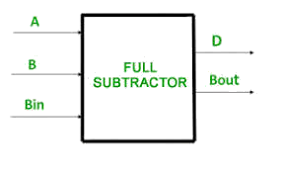  
**Figure-4: Logic Symbol of Full subtractor**  
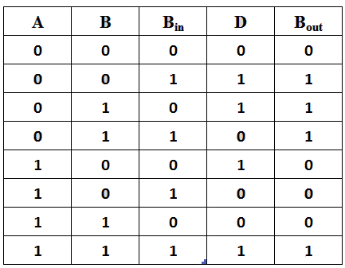  
Figure-5: Truth Table of Full subtractor

From the above truth table, we can find the Boolean expression.

**D = A ⊕ B ⊕ Bin  
B = A' Bin + A' B + B Bin**

From the equation we can draw the Full-subtractor circuit as shown in the figure 6.

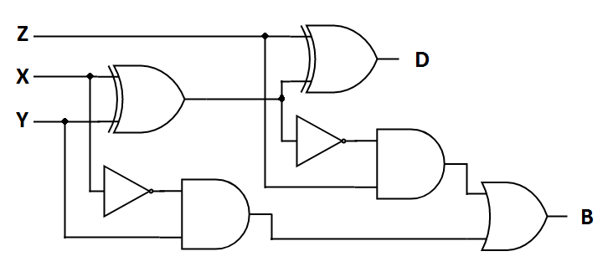  
**Figure-6: Circuit Diagram of Full subtractor**

**SIMULATION**

